|  |  |  |  |  |  |
| --- | --- | --- | --- | --- | --- |
| Date | 28-Nov-22 | | | Tester Name | Mayuri Patel |
| Environment | Penfax - Test | | | Login used |  |
| Operating System | Windows | Version: | Update: | | |
| Software Used | Edge | Version: | Update: | | |
| Not Applicable | Version: | Update: | | |
| Release version | 22.4.1 | | | | |
| Title | Death | | | | |
| Test Type | Regression | | | | |
| Test Scenario | Process a death payout to a spouse’s VPB | | | | |
|  |  | | | | |
| Expected Results | Beneficiary’s investment account should show the transferred amount in the same fund.  T4A should be generated for the member beneficiary and not for non-member beneficiary.  PEPP Payment to non-member letter should be generated for non-member beneficiary. | | | | |
| Pass/Fail | Pass | | | JIRA# | N/A |

Describe your steps with screenshots:

1. In PENFAX5 do a search for the deferred survivor member. Click on the stakeholder ID.

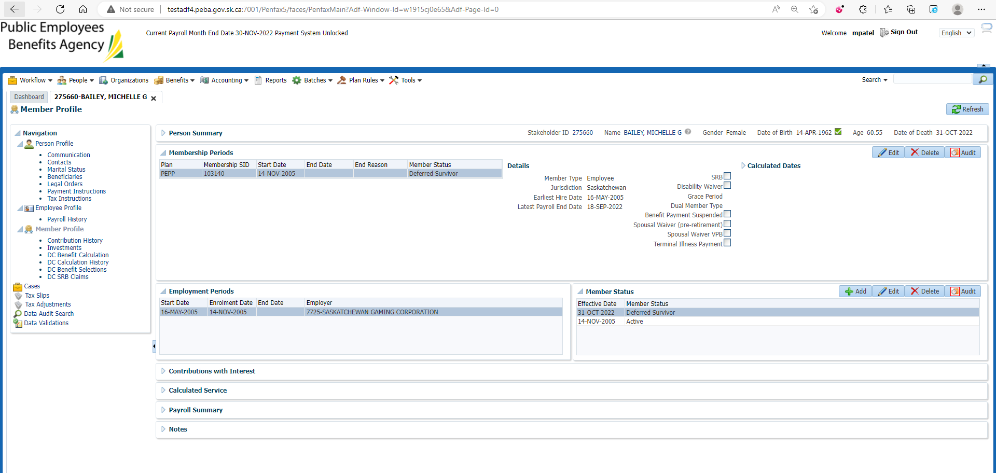

1. Click DC Benefit Selection. Click Add.

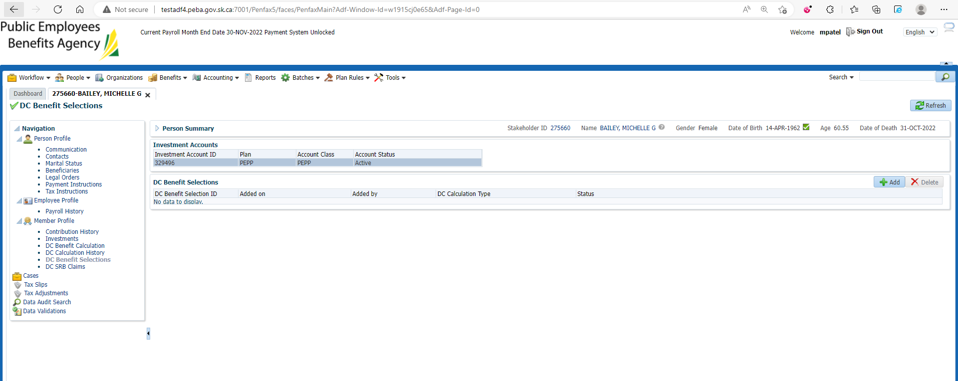

1. Verify Marital Status and Spouse Date of Birth and Death Date. Click Next.

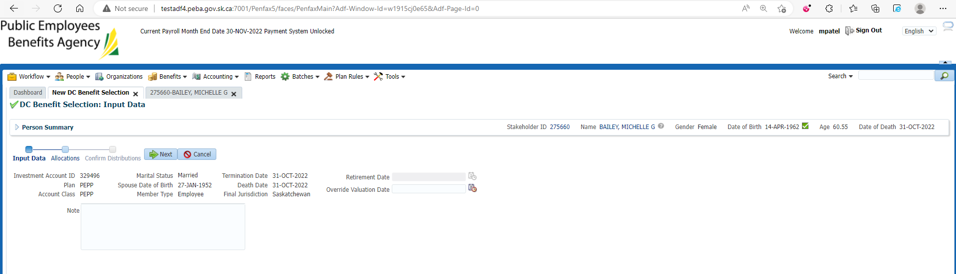

1. Click Add.

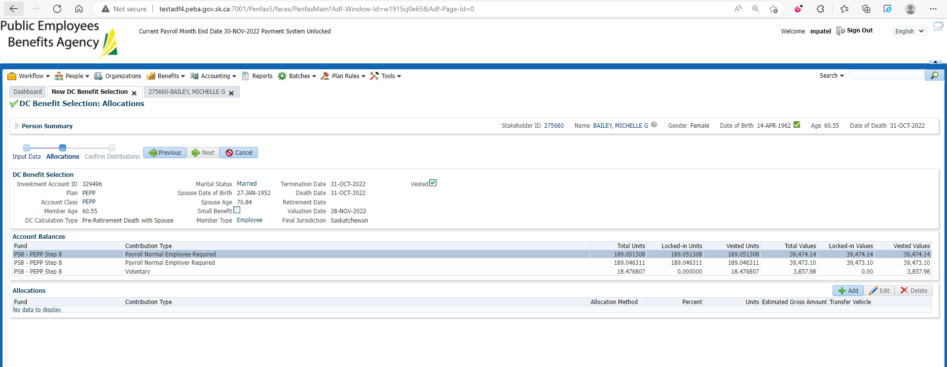

1. Select/input all the details and click on save. Repeat this for all the funds and all the contribution types.

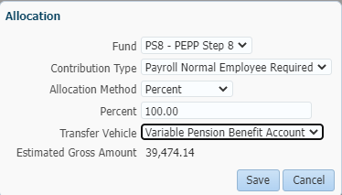

1. Once done, you can see all the records under Allocations. Click Next.

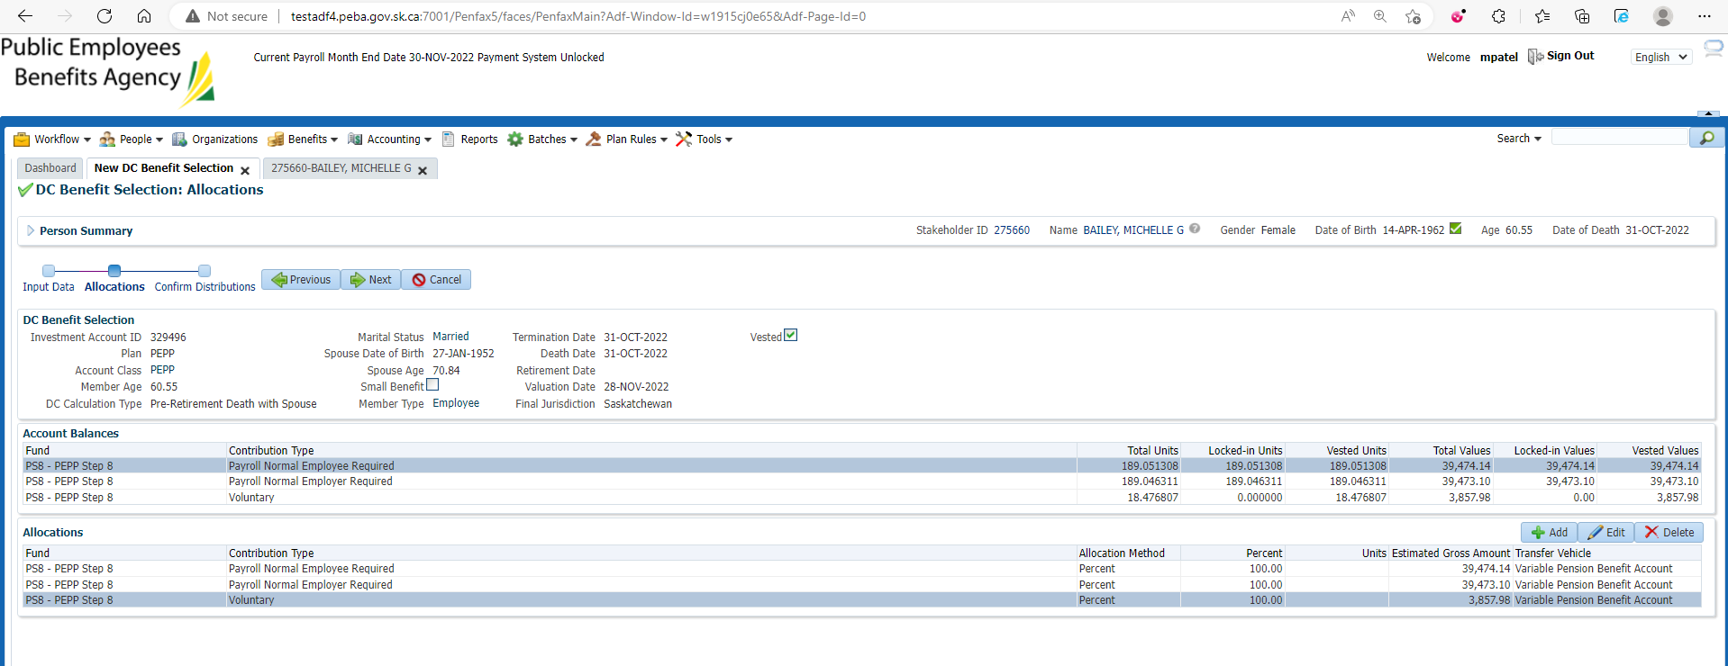

1. Click Submit for Approval.

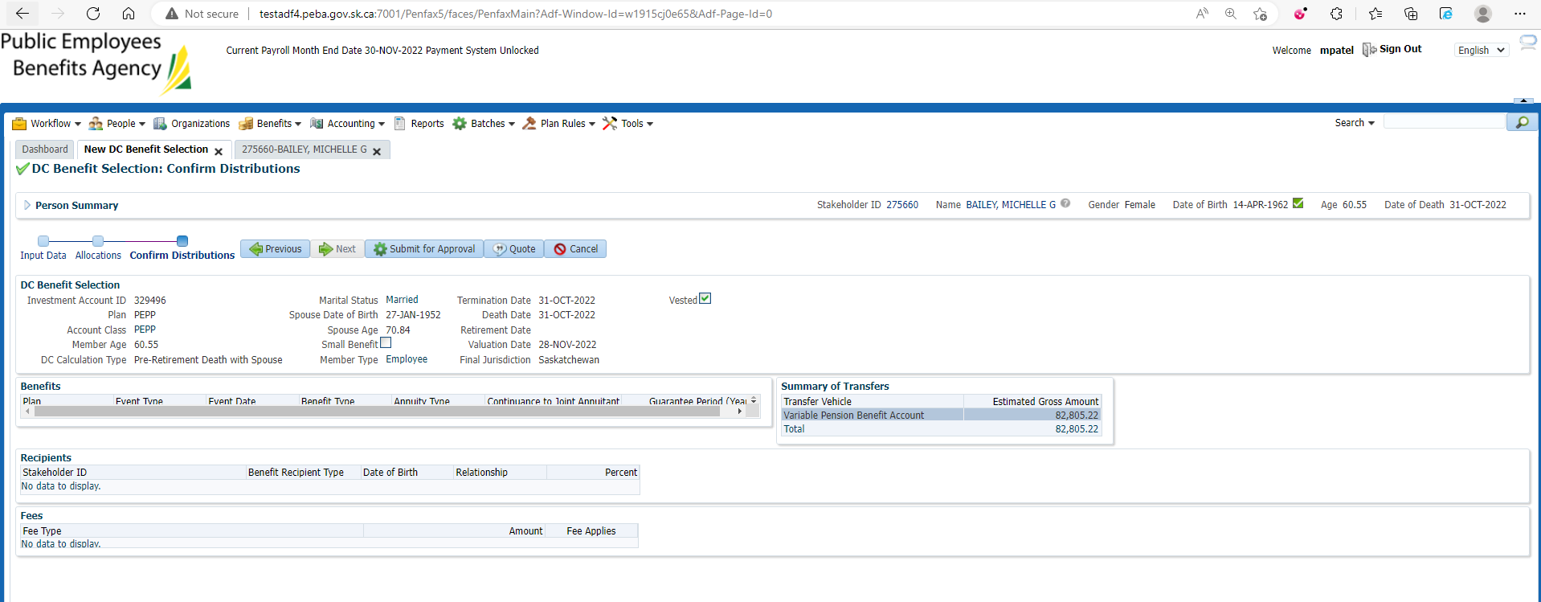

1. Verify all the details and click on Approve.

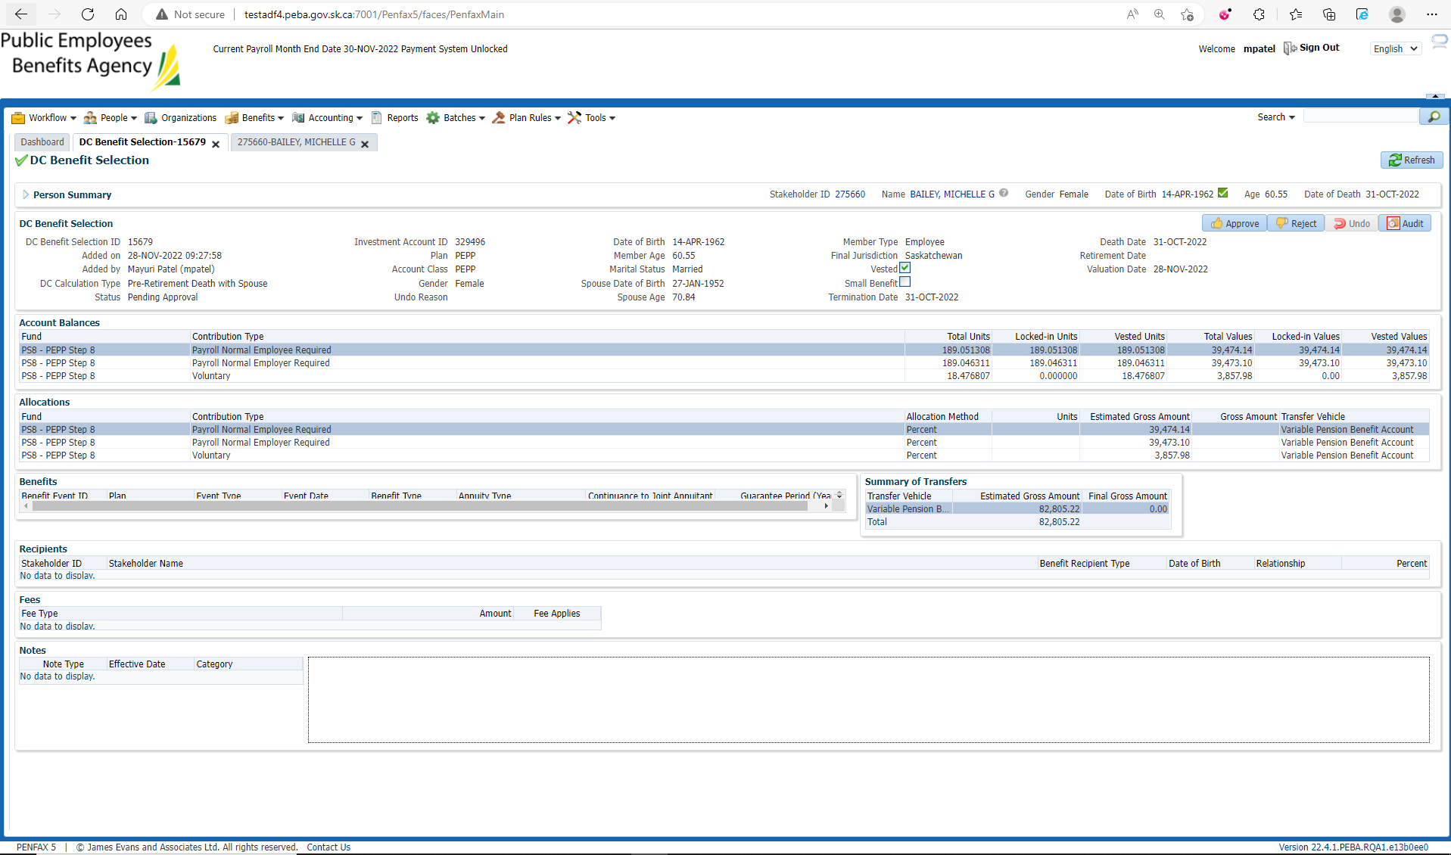

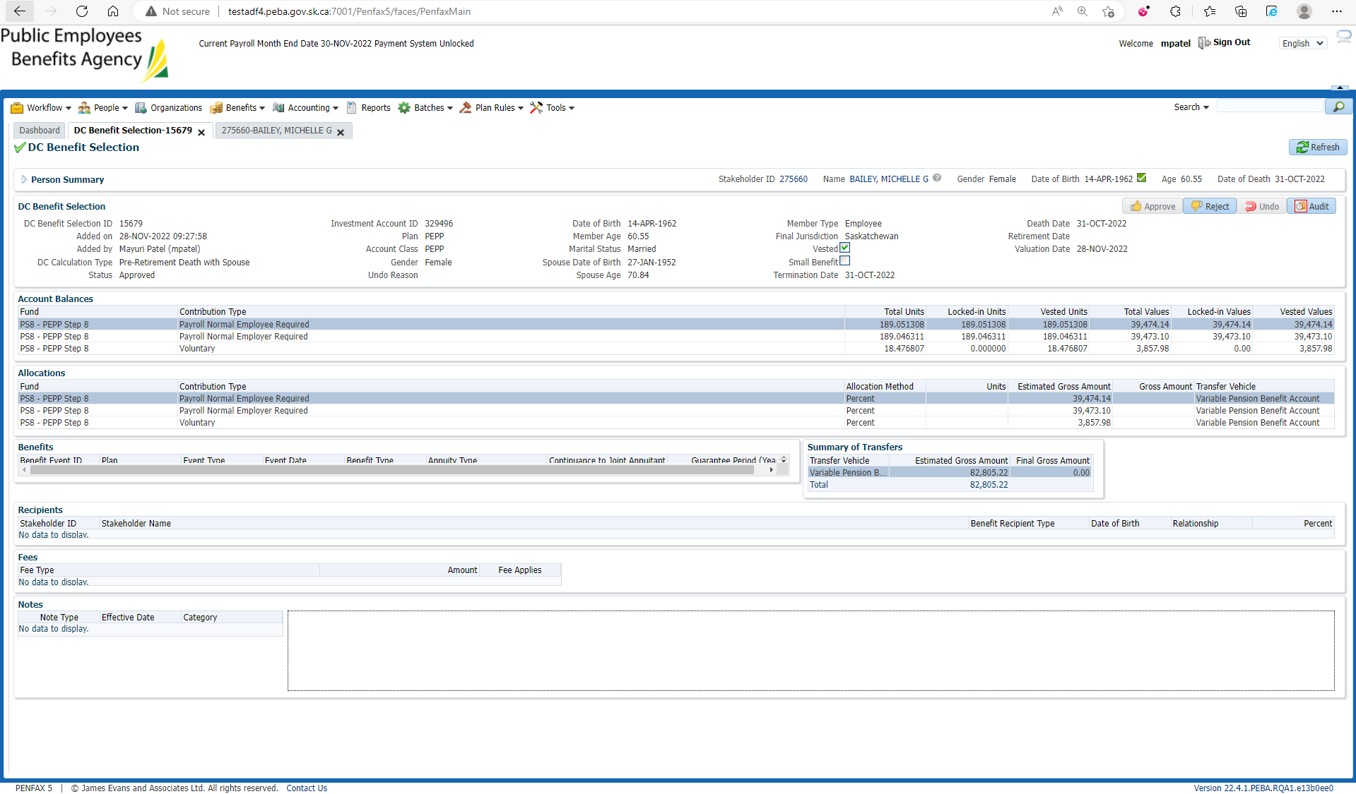

1. You can find the record of DC Benefit Selection under Member Profile -> DC Benefit Selections.

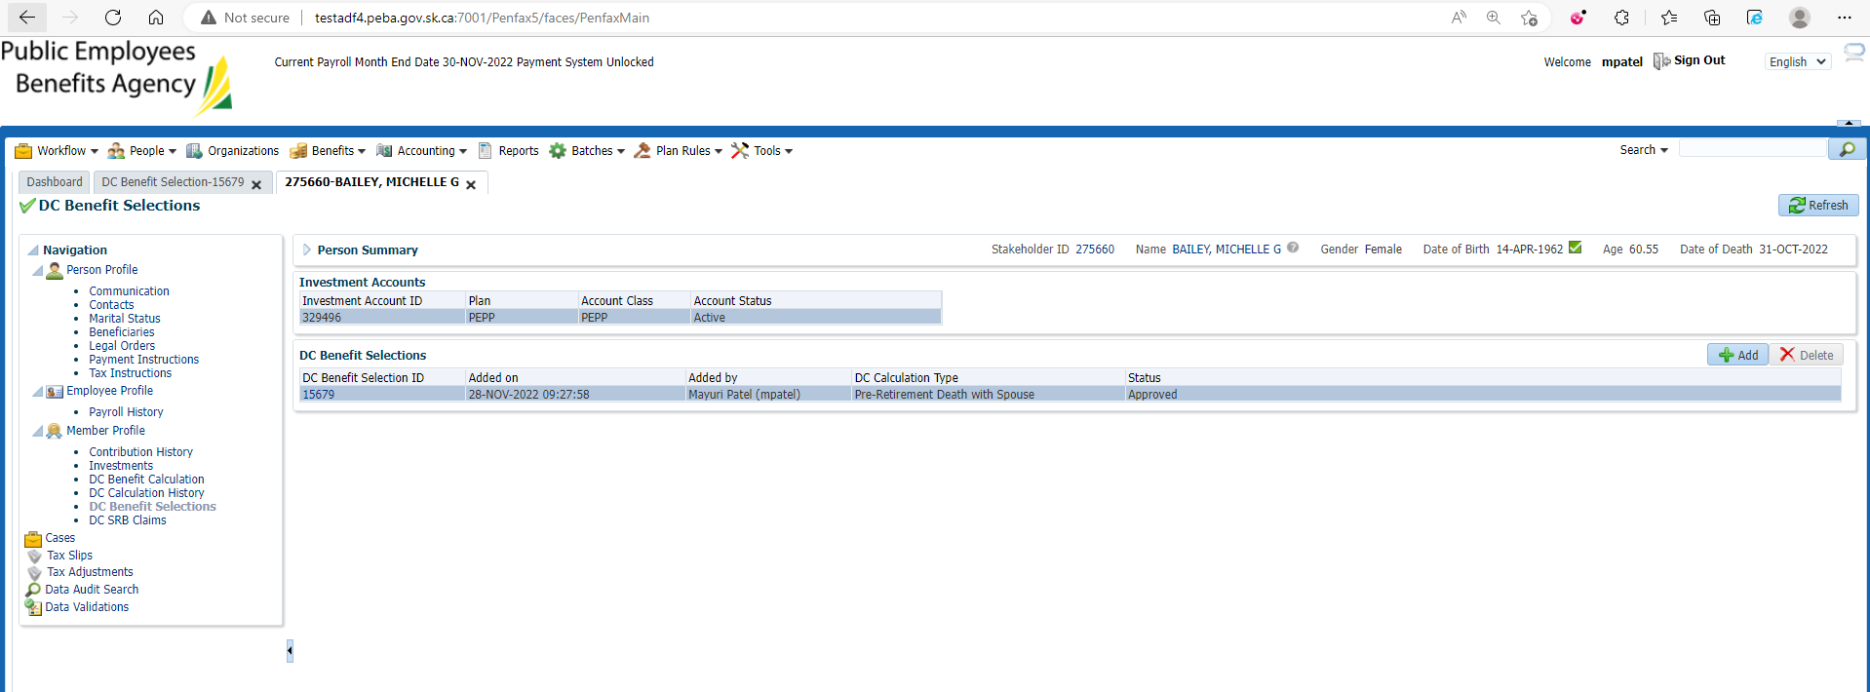

1. Wait for the overnight processes to run.
2. Bring up the Deceased Member again.

Click on Investments.

Make sure the account balance is 0.

Make sure the Account status is Inactive.

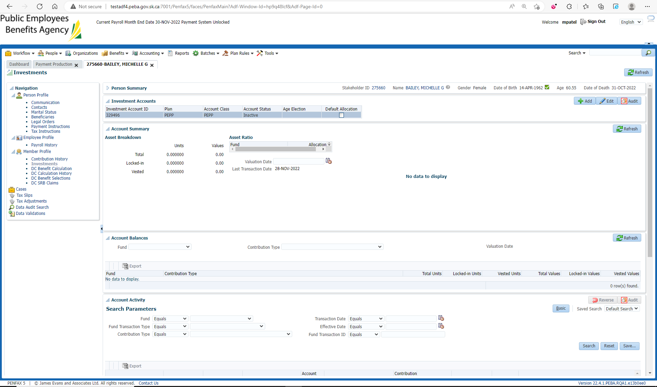

1. Go to Member Profile. Make sure Member Status is Death.

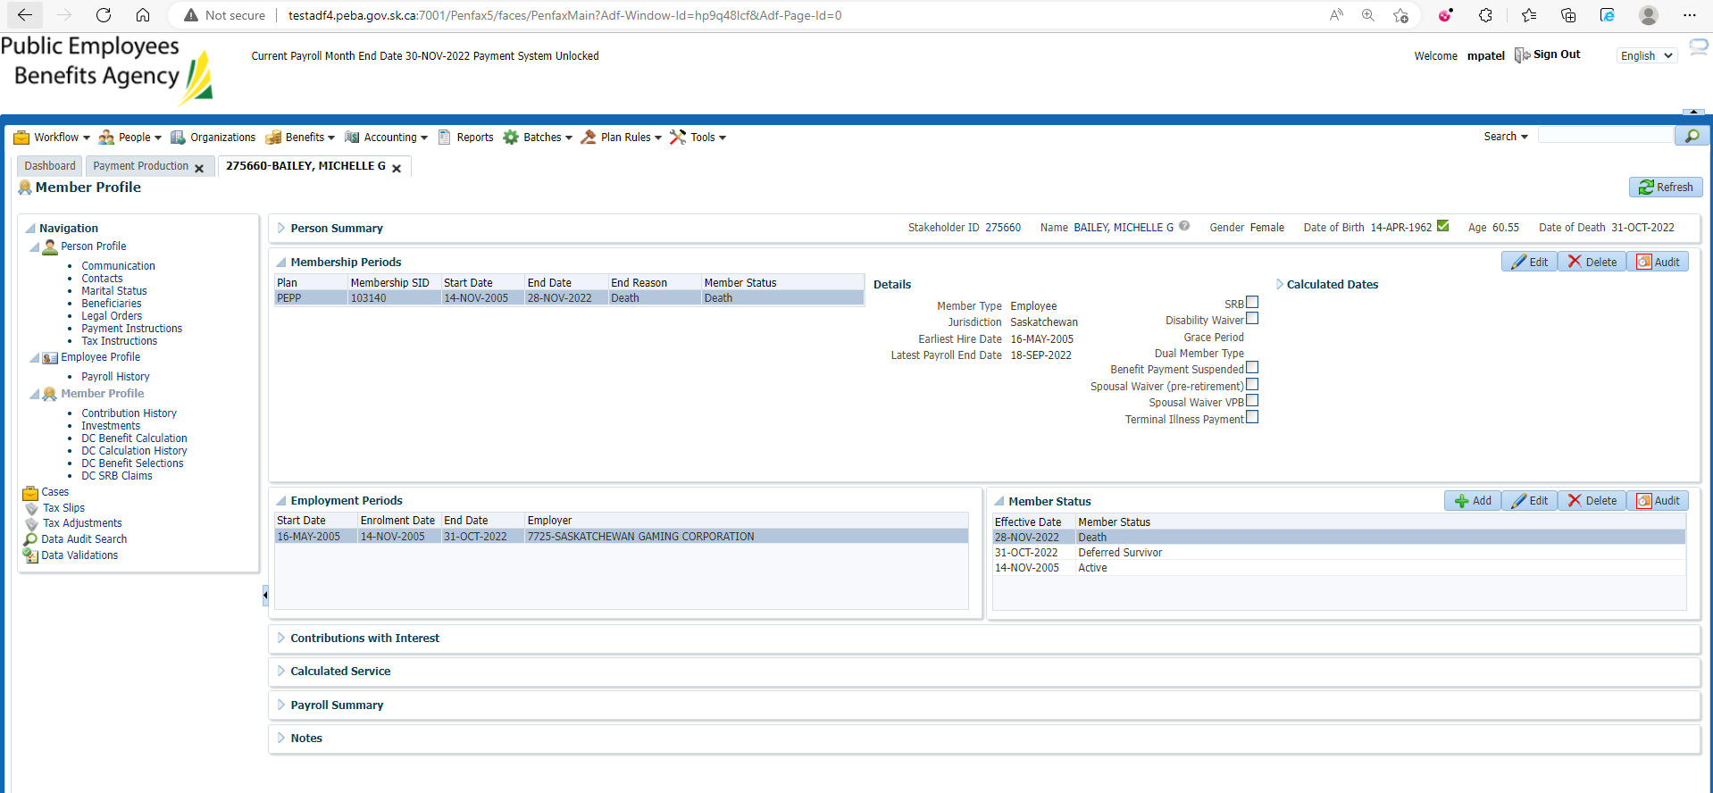

1. Go to the spouse that rec'd the benefit. Member should have a VPB Plan that is active.

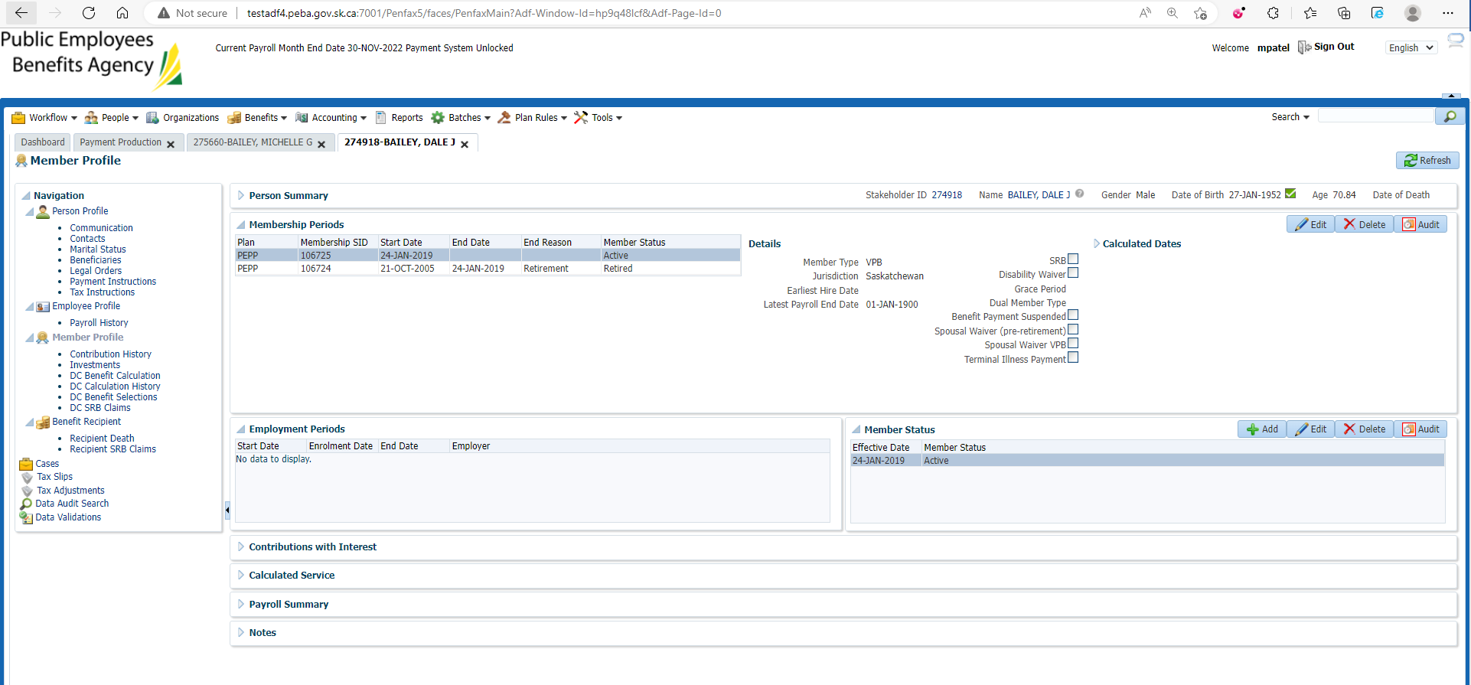

1. Go to Investments. Member should have a balance.

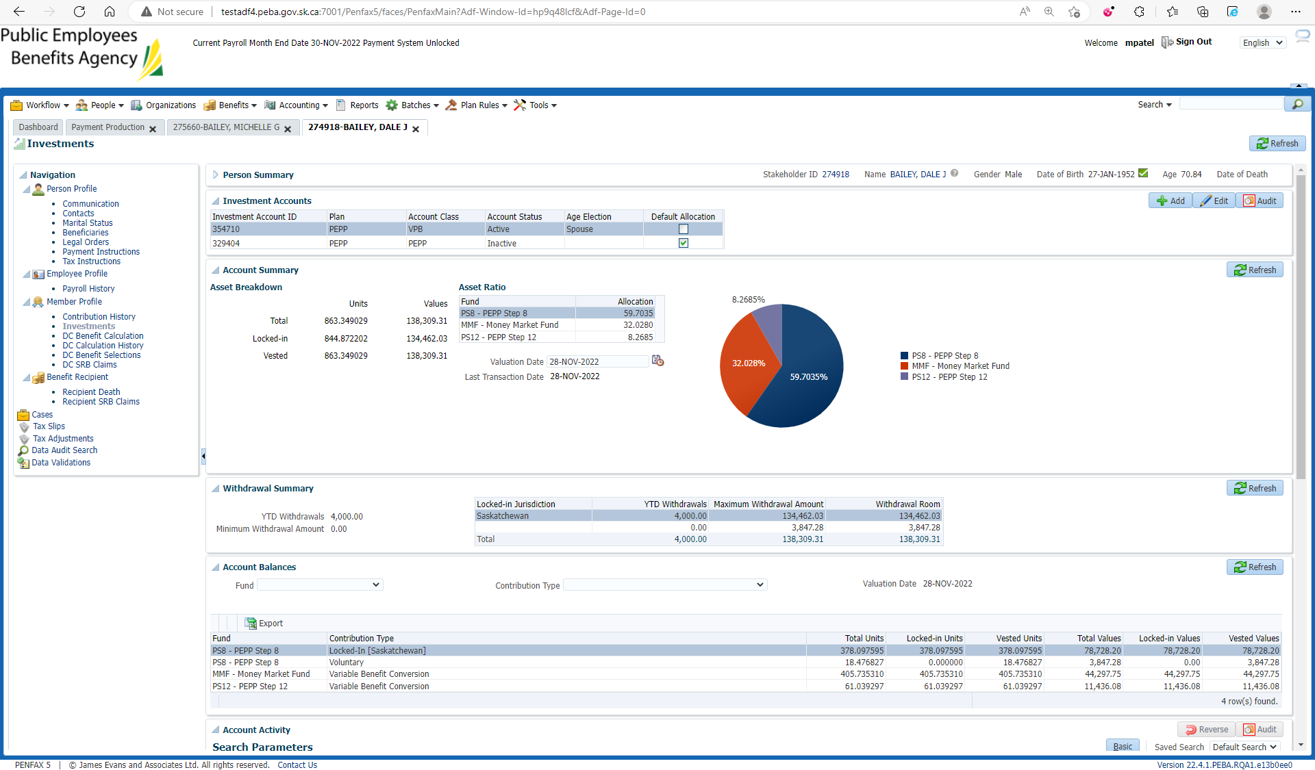

1. Go to Tax Slips. T4A should have been generated.

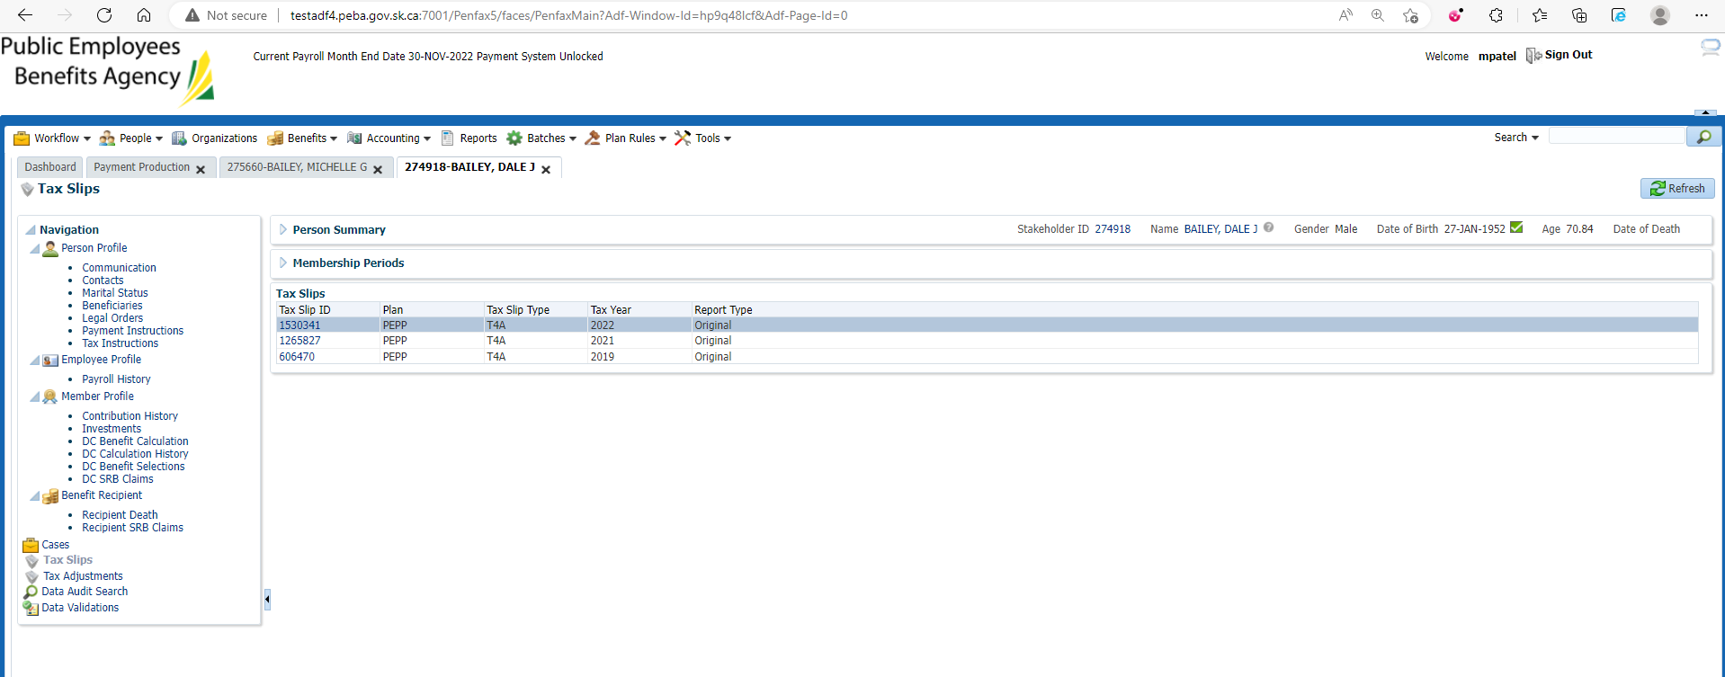

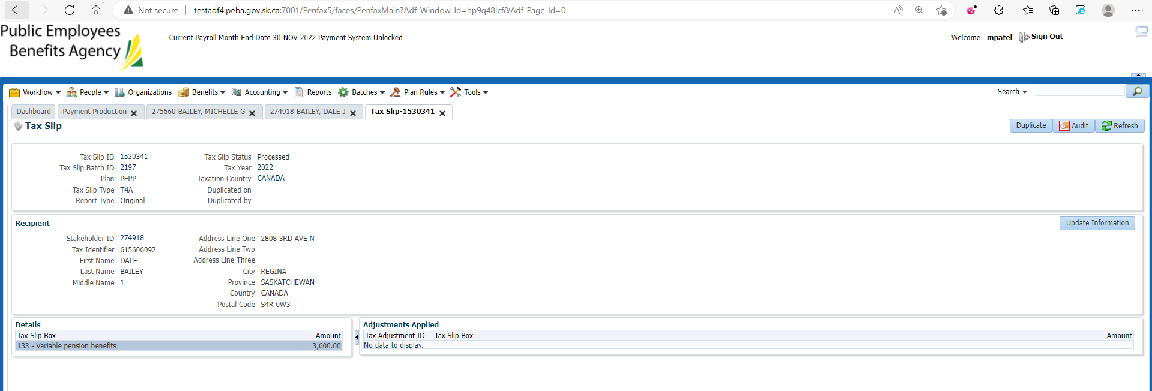

1. Go to Communication. Under Outbound Documents, T4A should be generated.

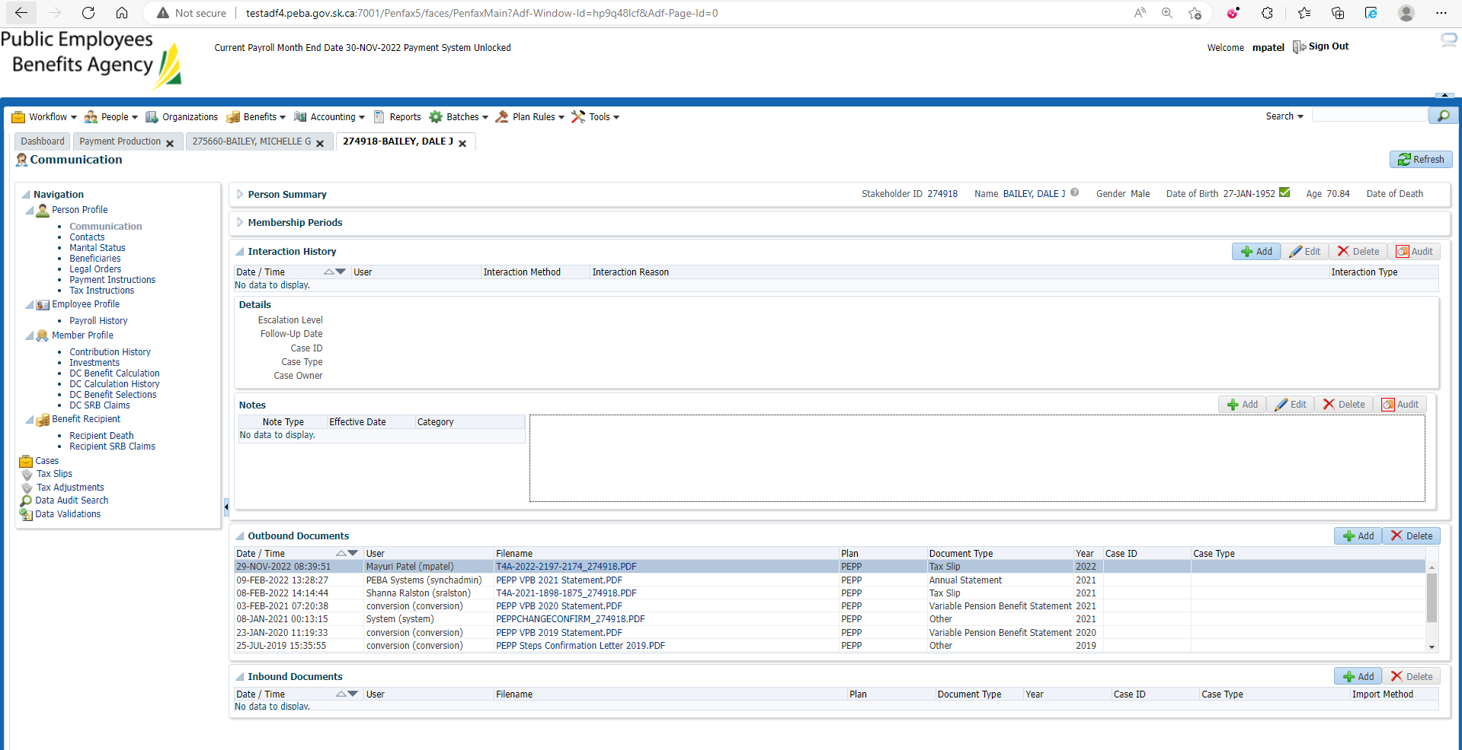

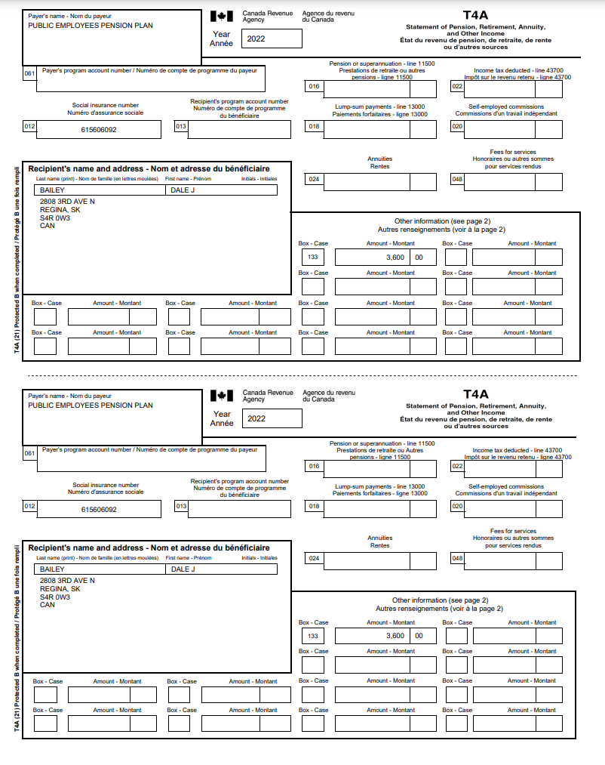

Note:

No letter generated under Member’s account as the beneficiary is an existing VPB member.